**Tue/Fri 6 Period**

Database Final Report

- User-Personalized Music Recommendation System -

Team C

21000048 김강산

21000494 이성경

21000759 최철웅

21200021 강진영

21300356 범가연

I.N.D.E.X

1. Program description 3

2. Database System Design (E/R Diagram and Relational Schema) 4

3. Program Functions and Query 8

4. Constraints (Foreign Keys) 20

5. Trigger 22

1. Program description
2. Description

: User-personalized music recommendation system.

Program analyzes user’s preference based on user’s selections. When user play music, download music, add music to play list and select genre and tempo preference, program scores user’s preference item by item; artist, genre, tempo. On the basis of these score, program recommends music.

1. User instruction

User can start the program by login or register. After login, user can use search and add music to playlist or download music which user want by enter the music index number that console shows. User also can manage play list by play music and remove music. In recommendation page, user selects genre and tempo preference. Based on user’s whole selections, program gives music recommendation list. User can add music to play list or download music, like search page. Also user can check one’s own preference.

1. Database System Design (E/R Diagram and Relational Schema)

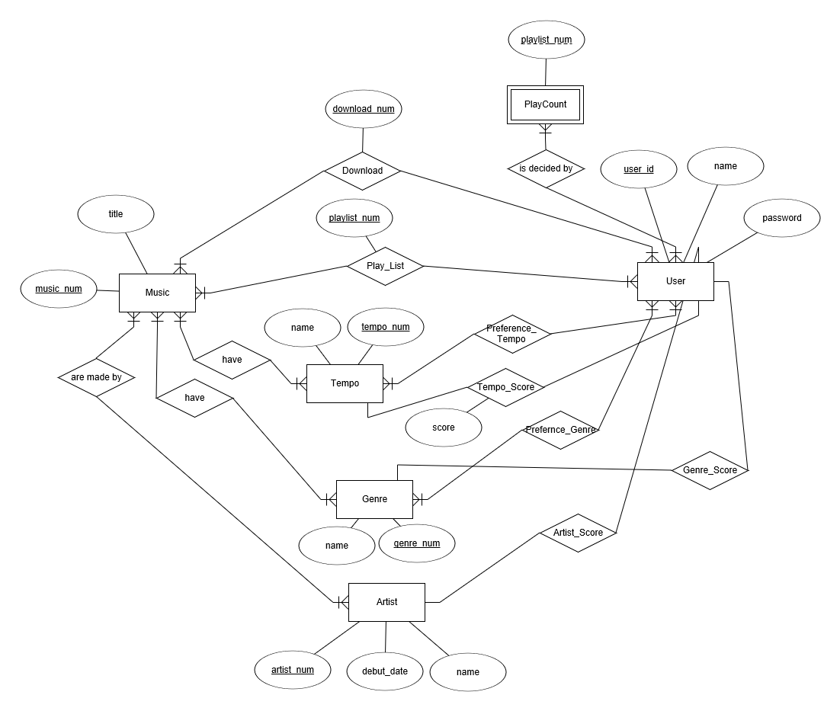

[Figure ] E/R Diagram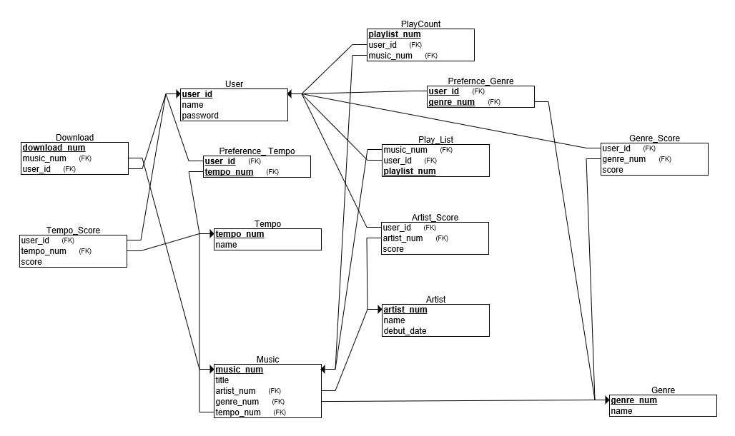

[Figure ] Relational Schema

Our system consists of 13 Tables.

1. Artist

It has three attributes.

“Artist_num” is an index attribute.

“Name” is an attribute, which indicates Artist’s name.

“Debut_data” is an attribute, which shows Artist’s Debut date.

1. Artist_Score

It has three attributes.

“User_id” is Foreign key, which references [User] table and indicates user’s id.

“Artist_num” is Foreign key, which references [Artist] table.

“Score” is attribute to save each Artist’s score

1. Download

It has three attributes.

“Download_num” is an index attribute.

“Music_num” is Foreign key, which references [Music] table and indicates music’s index.

“User_id” is Foreign key, which references [User] table and indicates user’s id.

1. Genre

It has two attributes.

“Genre_num” is an index attribute.

“Name” is an attribute, which indicates Genre’s type.

1. Genre_Score

It has three attributes.

“User_id” is Foreign key, which references [User] table and indicates User’s id.

“Genre_num” is Foreign key, which references [Genre] table and indicates Genre’s index.

“Score” is attribute to save each Genre’s Score.

1. Music

It has five attributes.

“Music_num” is index attribute.

“Title” is attribute to indicate music title.

“Genre_num” is Foreign key, which references [Genre] table and indicates Genre’s index.

“Tempo_num” is Foreign key, which references [Tempo] table and indicates Tempo’s index.

“Artist_num” is Foreign key, which references [Artist] table and indicates Artist’s index.

1. Play_Count

It has three attributes.

“Music_num” is Foreign key, which references [Music] table and indicates Music’s index.

“User_id” is Foreign key, which references [User] table and indicates User’s id.

“Play_Count” is attribute to count how the music plays.

1. Play_List

It has three attributes.

“Playlist_num” is index attribute.

“User id” is Foreign key, which references [User] table and indicates User’s id.

“Music_num” is Foreign key, which references [Music] table and indicates Music’s index.

1. Preference_Genre

It has two attributes.

“Genre_num” is Foreign key, which references [Genre] table and indicates Genre’s index.

“User_id” is Foreign key, which references [User] table and indicates User’s id.

1. Preference_Tempo

It has two attributes.

“Tempo_num” is Foreign key, which references [Tempo] table and indicates Tempo’s index.

“User_id” is Foreign key, which references [User] table and indicates User’s id.

1. Tempo

It has two attributes.

“Tempo” is index attribute.

“Name” is attribute, which indicates Tempo’s type.

1. Tempo_Score

It has three attributes.

“User_id” is Foreign key, which references [User] table and indicates User’s id.

“Tempo_num” is Foreign key, which references [Tempo] table and indicates Tempo’s index.

“Score” is attribute to save each Tempo’s score.

1. User

It has three attributes.

“User_id” is attribute to indicate User’s id.

“Name” is attribute to show User’s name.

“Password” is attribute to indicate User’s password.

1. Program Functions and Query
2. **Register**

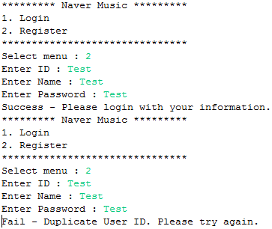

When user select menu number 2, program require some information ( ID, Name, Password ). If there is duplicate user id, then print error message.

**Query**

String query = "INSERT INTO User (user_id, name, password) VALUES ('"+id+"', '"+name+"', '"+password+"')";

Insert information to User table.

1. **Login**

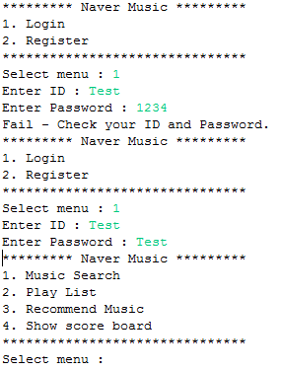

When user select menu number 1, program require information user id and password. If there is no matching with Database, then print error message. But if there is matching with Database, then print success message and print Main menu.

**Query**

String query = "SELECT * FROM User where user_id='" + id + "' and password='" + password + "' LIMIT 1";

Compare user input information with User table.

1. **Music Search**

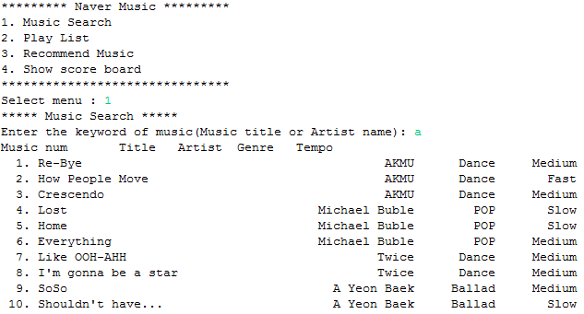

When user select menu number 1, program require some keyword of music(title or artist). If user input keyword, then program print all music list that including keyword. And print next step menu.

**Query**

String query = "select * from "

+ "(select m.music_num, m.title, a.name as Aname, t.name as Tname, g.name as Gname "

+ "from Music as m , Artist as a, Tempo as t, Genre as g where m.artist_num=a.artist_num "

+ "and m.tempo_num=t.tempo_num and g.genre_num=m.genre_num) p " + "where title like '%" + keyword

+ "%' or Aname like '%" + keyword + "%' order by music_num asc;";

Select all music list including keyword.

1. **Add music to play list**

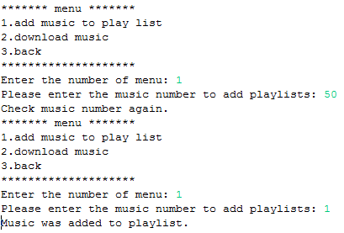

When user select menu number 1, program require music number. If user input number of music, then add music to play list table. If user input another character, print error message.

**Query**

query = "INSERT INTO Play_List (user_id, music_num) VALUES ('" + user_id + "', " + music_num + ");";

Insert information to Play_List table.

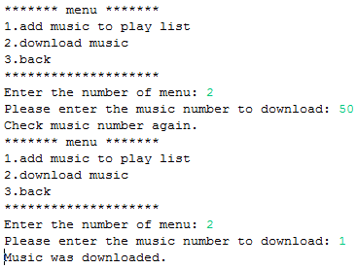

When user select menu number 2, program require music number. If user input number of music, then add music to download table. If user input another character, print error message.

**Query**

query = "INSERT INTO Download (music_num, user_id) VALUES ('" + music_num + "', '" + user_id + "');";

Insert information to Download table.

1. **Play List**

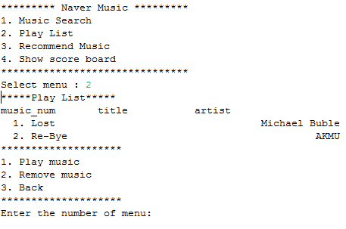

When user select menu number 2, program print all music in play list. And print sub menu.

**Query**

query = "SELECT * FROM (SELECT pl.playlist_num, m.*, a.name as Aname FROM Play_List as pl, Music as m, Artist as a "

+ "WHERE user_id = '" + user_id

+ "' and pl.music_num = m.music_num and m.artist_num = a.artist_num) p ;";

Select all music list in Play_List table.

1. **Play music**

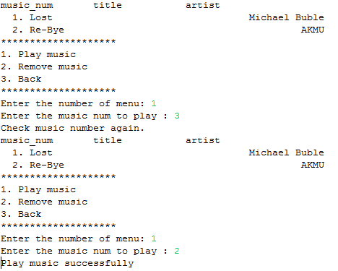

When user select menu number 1, program require number of music. If user input number, then update +1 play_count field in Play_Count table. If user input another character, print error message.

**Query**

query = "UPDATE Play_Count SET play_count = play_count + 1 WHERE user_id = '" + user_id + "' AND music_num='" + music_num + "';";

Update play_count +1 in Play_Count table.

1. **Remove music**

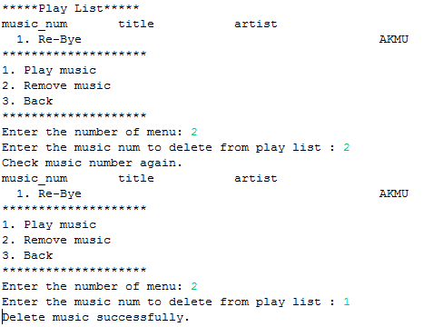

When user select menu number 1, program require number of music. If user input number, then delete from Play_Count table. If user input another character, print error message.

**Query**

query = "DELETE FROM Play_List WHERE playlist_num='" + playlist_num + "';";

Delete music in Play_Count table.

1. **Recommend music(First time)**

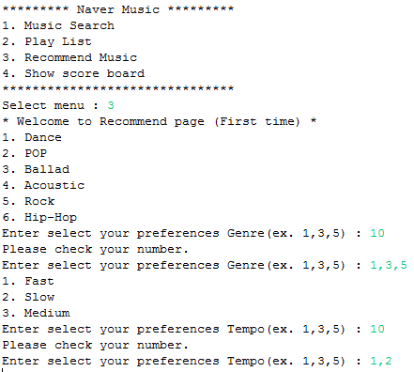

When user select menu number 3, if user visit this page at first, program require some information about user’s preference of music. If user input wrong numbers, print error message. If user input right numbers, print next step.

**Query**

query = "SELECT * FROM Genre";

Select all genre names.

query = "START TRANSACTION;";

query = "DELETE FROM Preference_Genre WHERE user_id='" + user_id + "'";

query = "INSERT INTO Preference_Genre (genre_num, user_id) VALUES ( '" + genre + "', '" + user_id + "' )";

query = "ROLLBACK";

query = "COMMIT";

Use transaction for user input something wrong character or not exist number. If user right numbers, then execute commit query, else execute rollback query.

query = "SELECT * FROM Tempo";

Select all tempo names.

query = "START TRANSACTION;";

query = "DELETE FROM Preference_Tempo WHERE user_id='" + user_id + "'";

query = "INSERT INTO Preference_Tempo (tempo_num, user_id) VALUES ( '" + tempo + "', '" + user_id + "' )";

query = "ROLLBACK";

query = "COMMIT";

Use transaction for user input something wrong character or not exist number. If user right numbers, then execute commit query, else execute rollback query.

1. **Recommend Music (after) – Show recommend music**

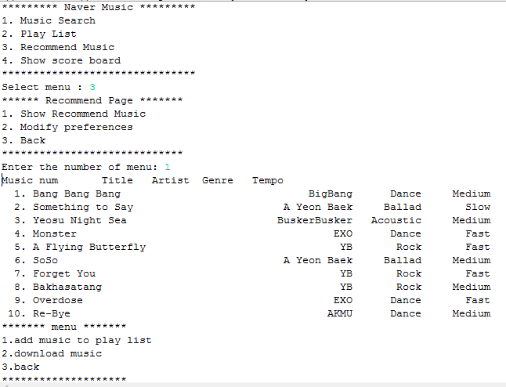

When user select menu number 1, program print 10 music randomized. Because of assumption that the recommend algorithm using score board is already implemented.

**Query**

query = "SELECT p.* FROM "

+ "(SELECT m.music_num, m.title, a.name as Aname, t.name as Tname, g.name as Gname "

+ "FROM Music as m , Artist as a, Tempo as t, Genre as g where m.artist_num=a.artist_num "

+ "AND m.tempo_num=t.tempo_num AND g.genre_num=m.genre_num) p "

+ "ORDER BY RAND() LIMIT 10;";

Select 10 music randomized.

1. **Recommend Music (after) – Modify preferences**

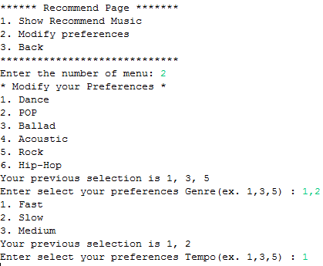

When user select menu number 2, program print preference list with previous selected. Another implementation are same with visit at first time.

**Query**

query = "SELECT * FROM Preference_Genre as pg WHERE pg.user_id='" + user_id + "'";

Select user’s previous selection in Preference_Genre table.

query = "SELECT * FROM Preference_Tempo as pt WHERE pt.user_id='" + user_id + "'";

Select user’s previous selection in Preference_Tempo table.

1. **Show score board**

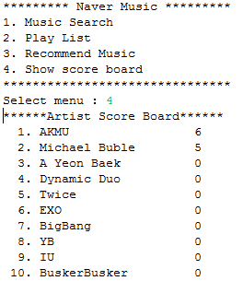

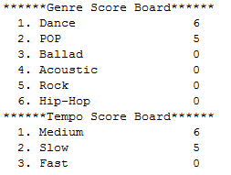

When user select menu number 4, program show score board about artist, genre, tempo that user interested.

**Query**

query = "SELECT a.name, IF(ars.score IS NULL, 0, ars.score) as score FROM Artist as a "

+ "LEFT OUTER JOIN Artist_Score as ars on ars.artist_num=a.artist_num AND ars.user_id='" + user_id + "' ORDER BY ars.score DESC";

Select artist score

query = "SELECT g.name, IF(gs.score IS NULL, 0, gs.score) as score FROM Genre as g "

+ "LEFT OUTER JOIN Genre_Score as gs on gs.genre_num=g.genre_num AND gs.user_id='" + user_id + "' ORDER BY gs.score DESC";

Select genre score

query = "SELECT t.name, IF(ts.score IS NULL, 0, ts.score) as score FROM Tempo as t "

+ "LEFT OUTER JOIN Tempo_Score as ts on ts.tempo_num=t.tempo_num AND ts.user_id='" + user_id + "' ORDER BY ts.score DESC";

Select tempo score.

1. Constraints (Foreign Keys)
2. **Artist_Score**

Use foreign keys to refer the information of Artist and User.

CONSTRAINT ‘fk_Artist_Score_artist_num’ FOREIGN KEY (‘artist_num’) REFERENCES ‘Artist’ (‘artist_num’)

CONSTRAINT ‘fk_Artist_Score_User_id’ FOREIGN KEY (‘User_id’) REFERENCES ‘User’ (‘User_id’)

1. **Genre_Score**

Use foreign keys to refer the information of Genre and User.

CONSTRAINT ‘fk_Genre_Score_genre_num’ FOREIGN KEY (‘genre_num’) REFERENCES ‘Genre’ (‘genre_num’)

CONSTRAINT ‘fk_Genre_Score_User_id’ FOREIGN KEY (‘User_id’) REFERENCES ‘User’ (‘User_id’)

1. **Tempo_Score**

Use foreign keys to refer the information of Tempo and User.

CONSTRAINT ‘fk_Tempo_Score_genre_num’ FOREIGN KEY (‘tempo_num’’) REFERENCES ‘Tempo’ (‘tempo_num’)

CONSTRAINT ‘fk_Tempo_Score_User_id’ FOREIGN KEY (‘User_id’) REFERENCES ‘User’ (‘User_id’)

1. **Download**

Use foreign keys to refer the information of User and Music.

CONSTRAINT ‘fk_download_User_id’ FOREIGN KEY (‘User_id’) REFERENCES ‘User’ (‘User_id’)

CONSTRAINT ‘fk_download_music_num’ FOREIGN KEY (‘music_num’) REFERENCES ‘Music’ (‘music_num’)

1. **Music**

Use foreign keys to refer the information of Artist, Tempo, and Genre.

CONSTRAINT ‘fk_music_aritst_num’ FOREIGN KEY (‘aritst_num’) REFERENCES ‘Artist’ (‘aritst_num’)

CONSTRAINT ‘fk_music_tempo_num’ FOREIGN KEY (‘tempo_num’) REFERENCES ‘Tempo’ (‘tempo_num’)

CONSTRAINT ‘fk_music_genre_num’ FOREIGN KEY (‘genre_num’) REFERENCES ‘Genre’ (‘genre_num’)

1. **Play_Count**

Use foreign keys to refer the information of User and Music.

CONSTRAINT ‘fk_play_count_User_id’ FOREIGN KEY (‘User_id’) REFERENCES ‘User’ (‘User_id’)

CONSTRAINT ‘fk_play_count_music_num’ FOREIGN KEY (‘music_num’) REFERENCES ‘Music’ (‘music_num’)

1. **Play_List**

Use foreign keys to refer the information of User and Music.

CONSTRAINT ‘fk_Play_List_User_id’ FOREIGN KEY (‘User_id’) REFERENCES ‘User’ (‘User_id’)

CONSTRAINT ‘fk_Play_List_music_num’ FOREIGN KEY (‘music_num’) REFERENCES ‘Music’ (‘music_num’)

1. **Preference_Genre**

Use foreign keys to refer the information of User and Genre.

CONSTRAINT ‘fk_preference_genre_User_id’ FOREIGN KEY (‘User_id’) REFERENCES ‘User’ (‘User_id’)

CONSTRAINT ‘fk_preference_genre_genre_num’ FOREIGN KEY (‘genre_num’) REFERENCES ‘Genre’ (‘genre_num’)

1. **Preference_Tempo**

Use foreign keys to refer the information of User and Tempo.

CONSTRAINT ‘fk_preference_tempo_User_id’ FOREIGN KEY (‘User_id’) REFERENCES ‘User’ (‘User_id’)

CONSTRAINT ‘fk_preference_tempo_num_genre_num’ FOREIGN KEY (‘tempo_num’) REFERENCES ‘Tempo’ (‘tempo_num’)

1. Trigger
2. **Add music to play list**

Scores of genre, tempo and artist related to the music increase 1 point.

When music is added to playlist, the new tuple is inserted to Play_List table. At this time, the trigger makes score of the table increase. If a related score tuple is already made, increase the score. Otherwise, insert a tuple that has 1 point.

Trigger: PlayList_To_Score

Event: INSERT

Table: Play_List

Statement: BEGIN

#In Genre_Score, if there is a tuple that has same genre_num with now added music and user_id

IF (SELECT EXISTS( SELECT *

FROM Genre_Score, Music

WHERE Genre_Score.user_id = NEW.user_id

AND NEW.music_num = Music.music_num

AND Genre_Score.genre_num = Music.genre_num) )

#If exist, update the value of score with set “score = score+1”

THEN

UPDATE Genre_Score SET Genre_Score.score = Genre_Score.score + 1

WHERE Genre_Score.user_id = new.user_id

AND Genre_Score.genre_num

IN ( SELECTMusic.genre_num FROM Music WHERE NEW.music_num = Music.music_num );

#otherwise, insert the tuple with the value of “user_id, genre_num, 1”

ELSE

INSERT INTO Genre_Score( user_id, genre_num )

SELECT new.user_id as user_id, genre_num

FROM Music

WHERE music_num = NEW.music_num;

END IF;

#In Artist_Score, if there is a tuple that has same artist_num with now added music and user_id

IF (SELECT EXISTS( SELECT *

FROM Artist_Score, Music

WHERE Artist_Score.user_id = NEW.user_id

AND NEW.music_num = Music.music_num

AND Artist_Score.artist_num = Music.artist_num) )

#If exist, update the value of score with set “score = score+1”

THEN

UPDATE Artist_Score SET Artist_Score.score = Artist_Score.score + 1

WHERE Artist_Score.user_id = new.user_id

AND Artist_Score.artist_num

IN ( SELECTMusic.artist_num FROM Music WHERE NEW.music_num = Music.music_num );

#otherwise, insert the tuple with the value of “user_id, artist_num, 1”

ELSE

INSERT INTO Artist_Score( user_id, artist_num )

SELECT new.user_id as user_id, artist_num

FROM Music

WHERE music_num = NEW.music_num;

END IF;

#In Tempo_Score, if there is a tuple that has same tempo_num with now added music and user_id

IF (SELECT EXISTS( SELECT *

FROM Tempo_Score, Music

WHERE Tempo_Score.user_id = NEW.user_id

AND NEW.music_num = Music.music_num

AND Tempo_Score.tempo_num = Music.tempo_num) )

#If exist, update the value of score with set “score = score+1”

THEN

UPDATE Tempo_Score SET Tempo_Score.score = Tempo_Score.score + 1

WHERE Tempo_Score.user_id = new.user_id

AND Tempo_Score.tempo_num

IN ( SELECTMusic.tempo_num FROM Music WHERE NEW.music_num = Music.music_num );

#otherwise, insert the tuple with the value of “user_id, tempo_num, 1”

ELSE

INSERT INTO Tempo_Score( user_id, tempo_num )

SELECT new.user_id as user_id, tempo_num

FROM Music

WHERE music_num = NEW.music_num;

END IF;

END

1. **Play music**

Scores of genre, tempo and artist related to the music increase 1 point.

When music playing, the value play_count is updated. At this time, the trigger makes score of the table increase. If a related score tuple is already made, increase the score. Otherwise, insert a tuple that has 1 point.

Trigger: Play_To_Score

Event: UPDATE

Table: Play_Count

Statement: BEGIN

#In Artist_Score, if there is a tuple that has same artist_num with now played music and user_id

IF EXISTS( SELECT *

FROM Artist_Score, Music

WHERE Artist_Score.user_id = NEW.user_id

AND NEW.music_num = Music.music_num

AND Artist_Score.artist_num = Music.artist_num)

THEN

#If exist, update the value of score with set “score = score+1”

UPDATE Artist_Score SET score = score + 1

WHERE Artist_Score.user_id = NEW.user_id

AND Artist_Score.artist_num

IN (SELECT artist_num

FROM Music

WHERE NEW.music_num = Music.music_num );

#otherwise, insert the tuple with the value of “user_id, artist_num, 1”

ELSE

INSERT INTO Artist_Score( user_id, artist_num, score )

SELECT new.user_id, artist_num, '1'

FROM Music

WHERE music_num = NEW.music_num;

END IF;

#In Genre_Score, if there is a tuple that has same genre_num with now played music and user_id

IF EXISTS( SELECT *

FROM Genre_Score, Music

WHERE Genre_Score.user_id = NEW.user_id

AND NEW.music_num = Music.music_num

AND Genre_Score.genre_num = Music.genre_num)

#If exist, update the value of score with set “score = score+1”

THEN UPDATE Genre_Score SET score = score + 1

WHERE Genre_Score.user_id = NEW.user_id

AND Genre_Score.genre_num

IN (SELECT Music.genre_num

FROM Music

WHERE NEW.music_num = Music.music_num );

#otherwise, insert the tuple with the value of “user_id, genre_num, 1”

ELSE

INSERT INTO Genre_Score( user_id, genre_num, score )

SELECT new.user_id, genre_num, '1'

FROM Music

WHERE music_num = NEW.music_num;

END IF;

#In Tempo_Score, if there is a tuple that has same tempo_num with now played music and user_id

IF EXISTS( SELECT *

FROM Tempo_Score, Music

WHERE Tempo_Score.user_id = NEW.user_id

AND NEW.music_num = Music.music_num

AND Tempo_Score.tempo_num = Music.tempo_num)

#If exist, update the value of score with set “score = score+1”

THEN UPDATE Tempo_Score SET score = score + 1

WHERE Tempo_Score.user_id = NEW.user_id

AND Tempo_Score.tempo_num

IN (SELECT Music.tempo_num

FROM Music

WHERE NEW.music_num = Music.music_num );

#otherwise, insert the tuple with the value of “user_id, tempo_num, 1”

ELSE

INSERT INTO Tempo_Score( user_id, tempo_num, score )

SELECT new.user_id, tempo_num, '1'

FROM Music

WHERE music_num = NEW.music_num;

END IF;

END

1. **Download music**

Scores of genre, tempo and artist related to the music increase 5 point.

When music downloaded, the new tuple is inserted to the Download table. At this time, the trigger makes score of the table increase. If a related score tuple is already made, increase the score. Otherwise, insert a tuple that has 5 point.

Trigger: Download_To_Score

Event: INSERT

Table: Download

Statement: BEGIN

#In Artist_Score, if there is a tuple that has same artist_num with now downloaded music and user_id

IF EXISTS( SELECT *

FROM Artist_Score, Music

WHERE Artist_Score.user_id = NEW.user_id

AND NEW.music_num = Music.music_num

AND Artist_Score.artist_num = Music.artist_num )

#If exist, update the value of score with set “score = score+5”

THEN

UPDATE Artist_Score SET score = score + 5

WHERE Artist_Score.user_id = NEW.user_id

AND Artist_Score.artist_num

IN (SELECT artist_num

FROM Music

WHERE NEW.music_num = Music.music_num );

#otherwise, insert the tuple with the value of “user_id, artist_num, 5”

ELSE

INSERT INTO Artist_Score( user_id, artist_num, score )

SELECT new.user_id, artist_num,'5'

FROM Music

WHERE music_num=NEW.music_num;

END IF;

#In Genre_Score, if there is a tuple that has same genre_num with now downloaded music and user_id

IF EXISTS( SELECT *

FROM Genre_Score, Music

WHERE Genre_Score.user_id = NEW.user_id

AND NEW.music_num = Music.music_num

AND Genre_Score.genre_num = Music.genre_num )

#If exist, update the value of score with set “score = score+5”

THEN

UPDATE Genre_Score SET score = score + 5

WHERE Genre_Score.user_id = NEW.user_id

AND Genre_Score.genre_num

IN (SELECT Music.genre_num

FROM Music

WHERE NEW.music_num = Music.music_num );

#otherwise, insert the tuple with the value of “user_id, genre_num, 5”

ELSE

INSERT INTO Genre_Score( user_id, genre_num, score )

SELECT new.user_id, genre_num,'5'

FROM Music

WHERE music_num=NEW.music_num;

END IF;

#In Tempo_Score, if there is a tuple that has same tempo_num with now downloaded music and user_id

IF EXISTS( SELECT *

FROM Tempo_Score, Music

WHERE Tempo_Score.user_id = NEW.user_id

AND NEW.music_num = Music.music_num

AND Tempo_Score.tempo_num = Music.tempo_num )

#If exist, update the value of score with set “score = score+5”

THEN

UPDATE Tempo_Score SET score = score + 5

WHERE Tempo_Score.user_id = NEW.user_id

AND Tempo_Score.tempo_num

IN (SELECT Music.tempo_num

FROM Music

WHERE NEW.music_num = Music.music_num );

ELSE

#otherwise, insert the tuple with the value of “user_id, tempo_num, 1”

INSERT INTO Tempo_Score( user_id, tempo_num, score )

SELECT new.user_id, tempo_num,'5'

FROM Music

WHERE music_num=NEW.music_num;

END IF;

END

1. **Select genre preference**

Scores of the genre increase 10 point.

Once user selects genre preference, the tuple about user’s genre preference is deleted and re-inserted in Genre_Preference table. When delete, trigger decrease the score 10 and when increase the trigger gives 10 point related tuple in Genre_Score table. If the score tuple is already exist, increase the score. Otherwise, insert a tuple that has 10 point.

Trigger: Preference_Genre_Del_Trigger

Event: DELETE

Table: Preference_Genre

Statement: BEGIN

UPDATE Genre_Score SET Genre_Score.score = Genre_Score.score - 10 WHERE Genre_Sc

ore.user_id = OLD.user_id and Genre_Score.genre_num=OLD.genre_num;

END

Trigger: Preference_Genre_Ins_Trigger

Event: INSERT

Table: Preference_Genre

Statement: BEGIN

#If there is the tuple that has same information of genre and user

IF EXISTS( SELECT * FROM Genre_Score WHERE Genre_Score.user_id = NEW.user_id and

Genre_Score.genre_num = NEW.genre_num)

#then update the value of the score with score + 10

THEN

UPDATE Genre_Score SET Genre_Score.score = Genre_Score.score + 10 WHERE Genre_Sc

ore.user_id = new.user_id and Genre_Score.genre_num=NEW.genre_num;

#otherwise, insert new tuple with score 10

ELSE

INSERT INTO Genre_Score( user_id, genre_num, score) SELECT new.user_id, new.genr

e_num, '10';

END IF;

END

1. **Select tempo preference**

Scores of the tempo increase 10 point.

Once user selects tempo preference, the tuple about user’s tempo preference is deleted and re-inserted in Tempo_Preference table. When delete, trigger decrease the score 10 and when increase the trigger gives 10 point related tuple in Tempo_Score table. If the score tuple is already exist, increase the score. Otherwise, insert a tuple that has 10 point.

Trigger: Preference_Tempo_Del_Trigger

Event: DELETE

Table: Preference_Tempo

Statement: BEGIN

UPDATE Tempo_Score SET Tempo_Score.score = Tempo_Score.score - 10 WHERE Tempo_Score.user_id = OLD.user_id and Tempo_Score.tempo_num=OLD.tempo_num;

END

Trigger: Preference_Tempo_Ins_Trigger

Event: INSERT

Table: Preference_Tempo

Statement: BEGIN

#If there is the tuple that has same information of tempo and user

IF EXISTS( SELECT * FROM Tempo_Score WHERE Tempo_Score.user_id = NEW.user_id and

Tempo_Score.tempo_num = NEW.tempo_num)

#then update the value of the score with score + 10

THEN

UPDATE Tempo_Score SET Tempo_Score.score = Tempo_Score.score + 10 WHERE Tempo_Sc

ore.user_id = NEW.user_id and Tempo_Score.tempo_num=NEW.tempo_num;

ELSE

#otherwise, insert new tuple with score 10

INSERT INTO Tempo_Score( user_id, tempo_num, score) SELECT new.user_id, new.temp

o_num, '10';

END IF;

END